

| **14208971** | **Tharkana D Kodagoda** |
| --- | --- |
| 14208893 | Sahitha Nelanga H De Silva |
| 14208910 | H W Srimal Priyanga Fonseka |
| 14209059 | Dilina Namal Weerasinghe |
| 14209074 | P W Poorni Yasodara |
| 14209759 | Kavindu Yudeesha Lakshan Narathota |



**ABSTRACT**

**School of Computer Science and Informatics**

**University College Dublin**

This is the Final Project Report submitted for the Software Engineering Project I by team 6droids

* “FormCalc” is a software calculator which is implemented as a Computer Program, not as a physical hardware device. “FormCalc” is different from the standard calculators. It is different because, user doesn’t have to enter keys or commands each and every step in order to get the end result. It’s a symbolic calculator allows user to enter the formula in symbolic forms to generate/obtain the end result at once.
* “FormCalc” in other words, reflects a combination of a standard calculator app and a mathematical software package in your desktop.
* Special features
* Differentiation calculator
* Integral calculator
* Graphs creator
* Save and reload formulas / equations
* Quick access history recorder

Table of Contents

**1.0** **Project Specifications**

**1.1 Requirements**

1.1.1 Programming Language (C++)

1.1.2 IDE (QT Creator)

**1.2 Functionalities**

**1.3 Work – Package Overview**

**1.4 Work Breakdown Structure**

**2.0** **Software Implementation**

**2.1** **Flowchart Diagram**

**2.2** **Class Diagram**

**2.3** **Wireframes**

**2.4** **User Interface**

2.4.1 Splash Screen

2.4.2 Basic Calculator

2.4.3 Scientific Calculator

2.4.4 Advance Calculator

2.4.5 Graph Calculator

**3.0** **Analysis of Success / Failure**

**4.0** **Additional Features**

**5.0** **Team Analysis**

**5.1 Team Roles**

**6.0** **Conclusion**

# Project Specifications

**1.1 Requirements**

1.1.1 Programming Language (C++)

C++ is a middle-level programming language developed by Bjarne Stroustrup starting in 1979 at Bell Labs. C++ runs on a variety of platforms, such as Windows, Mac OS, and the various versions of UNIX.

C++ is a general-purpose programming language. It has imperative, object-oriented and generic programming features, while also providing the facilities for low-level memory manipulation.



1.1.2 IDE (QT Creator)

QT provides a large set of libraries as well as the GUI related things (ex XML parsing, threads, networking), all in a consistent style and all multi-platform. This means we rarely need to use other libraries, though we do use boost for some things.



**1.2 Functionalities**

1. **User Communication Interface**

The user has a provision of communicate with "FormCalc" by using text window. The user can enter formulae, evaluate formulae, request a graph of a formulae, etc. The text interface scrolls, to show previous commands that were entered.

User can use a graphical interface too. With buttons and read-out strip user may interact with "FormCalc" to enter expressions to be evaluated or graphed.

1. **Formula entry and storage**

A User can enter a formula through the text user interface and a given name to that formula. The stored expressions can be used in the recent future. If the given name of a formula already exists; "FormCalc" will ask whether the application should over-write the existing formula and associate it with the new formula.

1. **Formula Re-use**

The user is allowed to use a formula that has been introduced before as a function in another formula. The new formula should be introduced with a different name.

1. **Formula Evaluation**
2. **Formula Integration**

“FormCalc” can calculate the integral of any formula f() using numerical method. The integral function of a formula is indicated by the name of the formula in uppercase. That means the integral function of f() is F().

1. **Formula Graphing**
2. **Graphing Multiple Formula Simultaneously**
3. **Saving Formulae to a File**

The user is allowed to save memory of the formulae to a disk file (.xml file) by selecting save button in the graphical user interface or typing save in text interface. A file browser window will open in either case, allowing the user to specify a filename into which the formulae should be saved.

1. **Re-Loading Formulae From a File**
2. **Saving a Graph to a File**
3. **Find Area Under Curve**

**1.3 Work – Package Overview**

When implementing “FormCalc” software below mentioned main tasks were identified where they were further divided into multiple tasks.

1. **Requirement Analysis**

* Work Breakdown structure
* Project Sprint
* Developing Plan

1. **UI, UX and Prototyping**

* Wireframes
* High Fidelity
* UX & UI Review1

1. **Architecture**

* Flow Charts
* High Level Architecture
* UI Designing
* QA Release v0.0.1

1. **Development**

* Basic Math Functions
* History Implementation
* Formula Storage
* Formula Evaluation
* Formula Integration
* Formula Graphing
* Multiple Formula Graphing
* File Handling
* Bug Resolving

1. **Quality Assurance**

* Create Test Scenario
* Unit Testing
* Component Testing
* Integration Testing
* User Testing

1. **Documentation**

* Daily Scrum Notes
* Weekly Report
* Interim Report
* Final Report

1. **Deployment**

**1.4 Work Breakdown Structure**

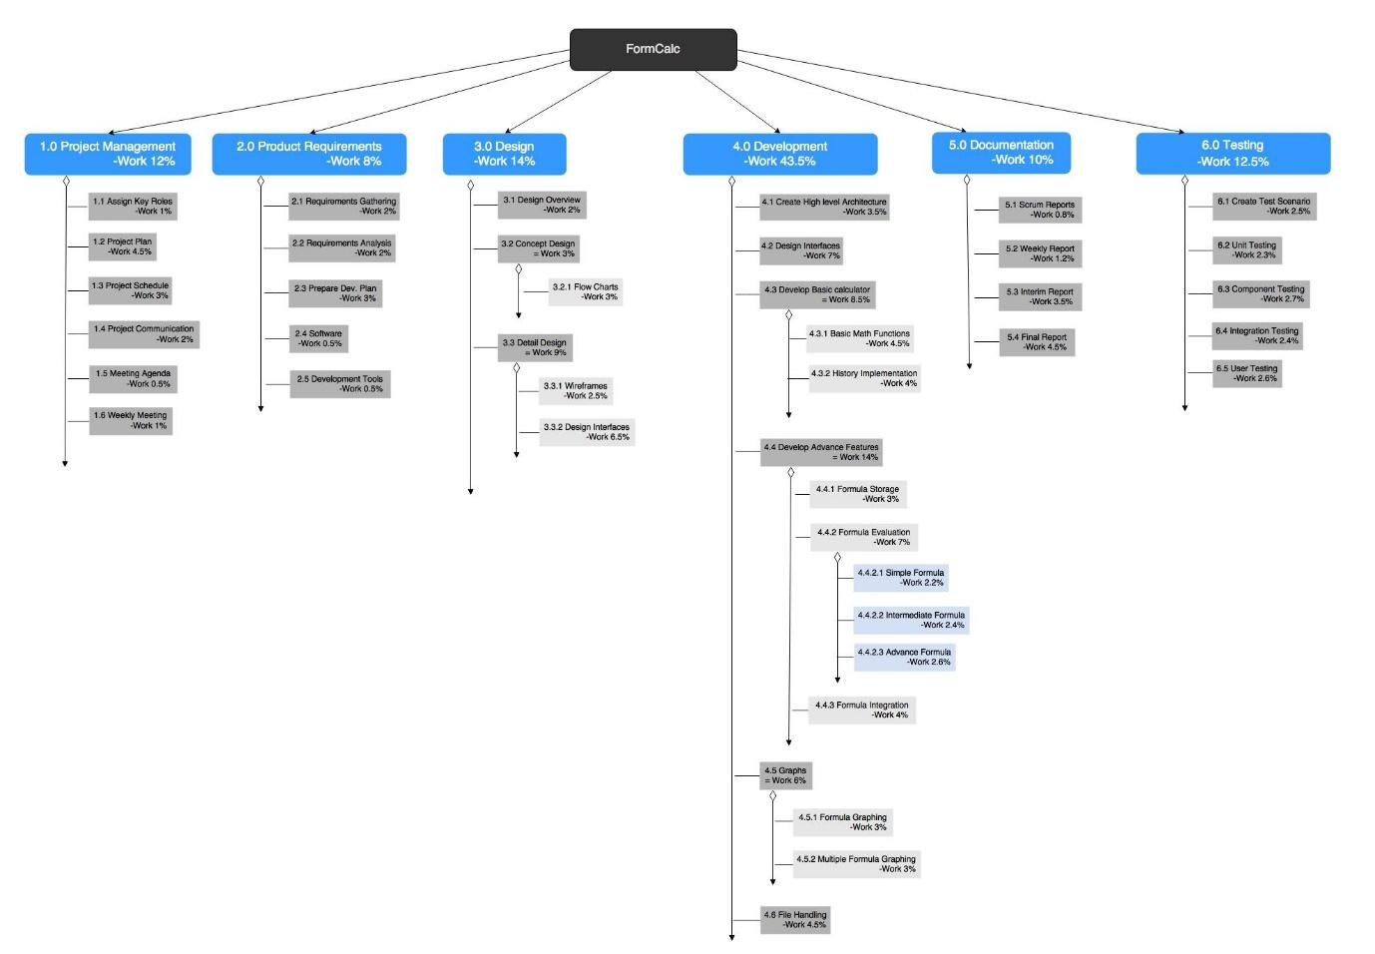

Read more - <https://goo.gl/l6xmJ6>

# Software Implementation

To make things easier, we divided the complete project into smaller divisions, so each member can take over one part and work on that. As we suggested, following divisions are created. We call it 3D structure.

* Designing team (Wireframes, UI)
* Dev team (Flowcharts, Development)
* Documentation, Testing and QA team (Reports, QA)

So these are the tasks which these teams must achieve by end of the project.

* Research and Development
* Requirement Analysis
* UI,UX and Prototyping
* Architecture
* Development
* Quality Assurance
* Documentation
* Deployment

## **Flowchart Diagram**

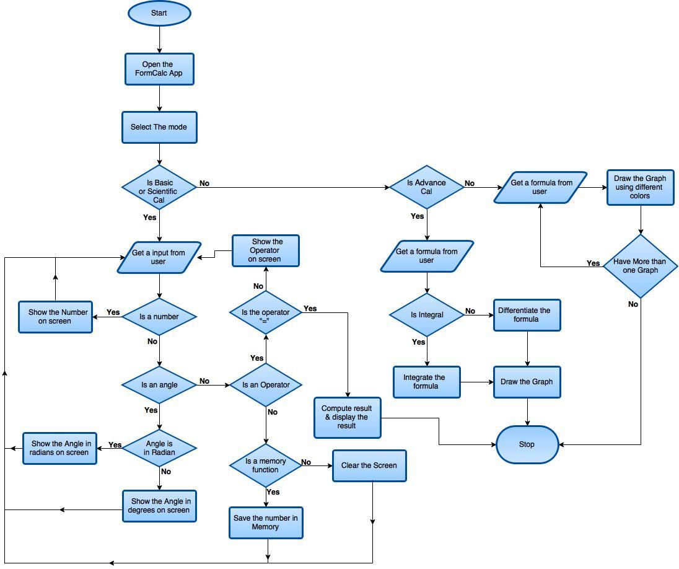

Read more - <https://goo.gl/s7SNY6>

## **Class Diagram**

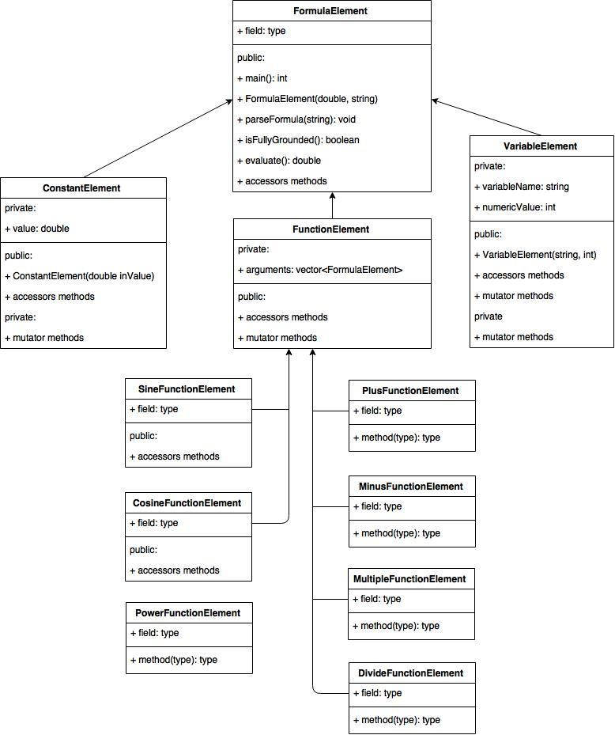

Read more - <https://goo.gl/5OTS14>

## **Wireframes**

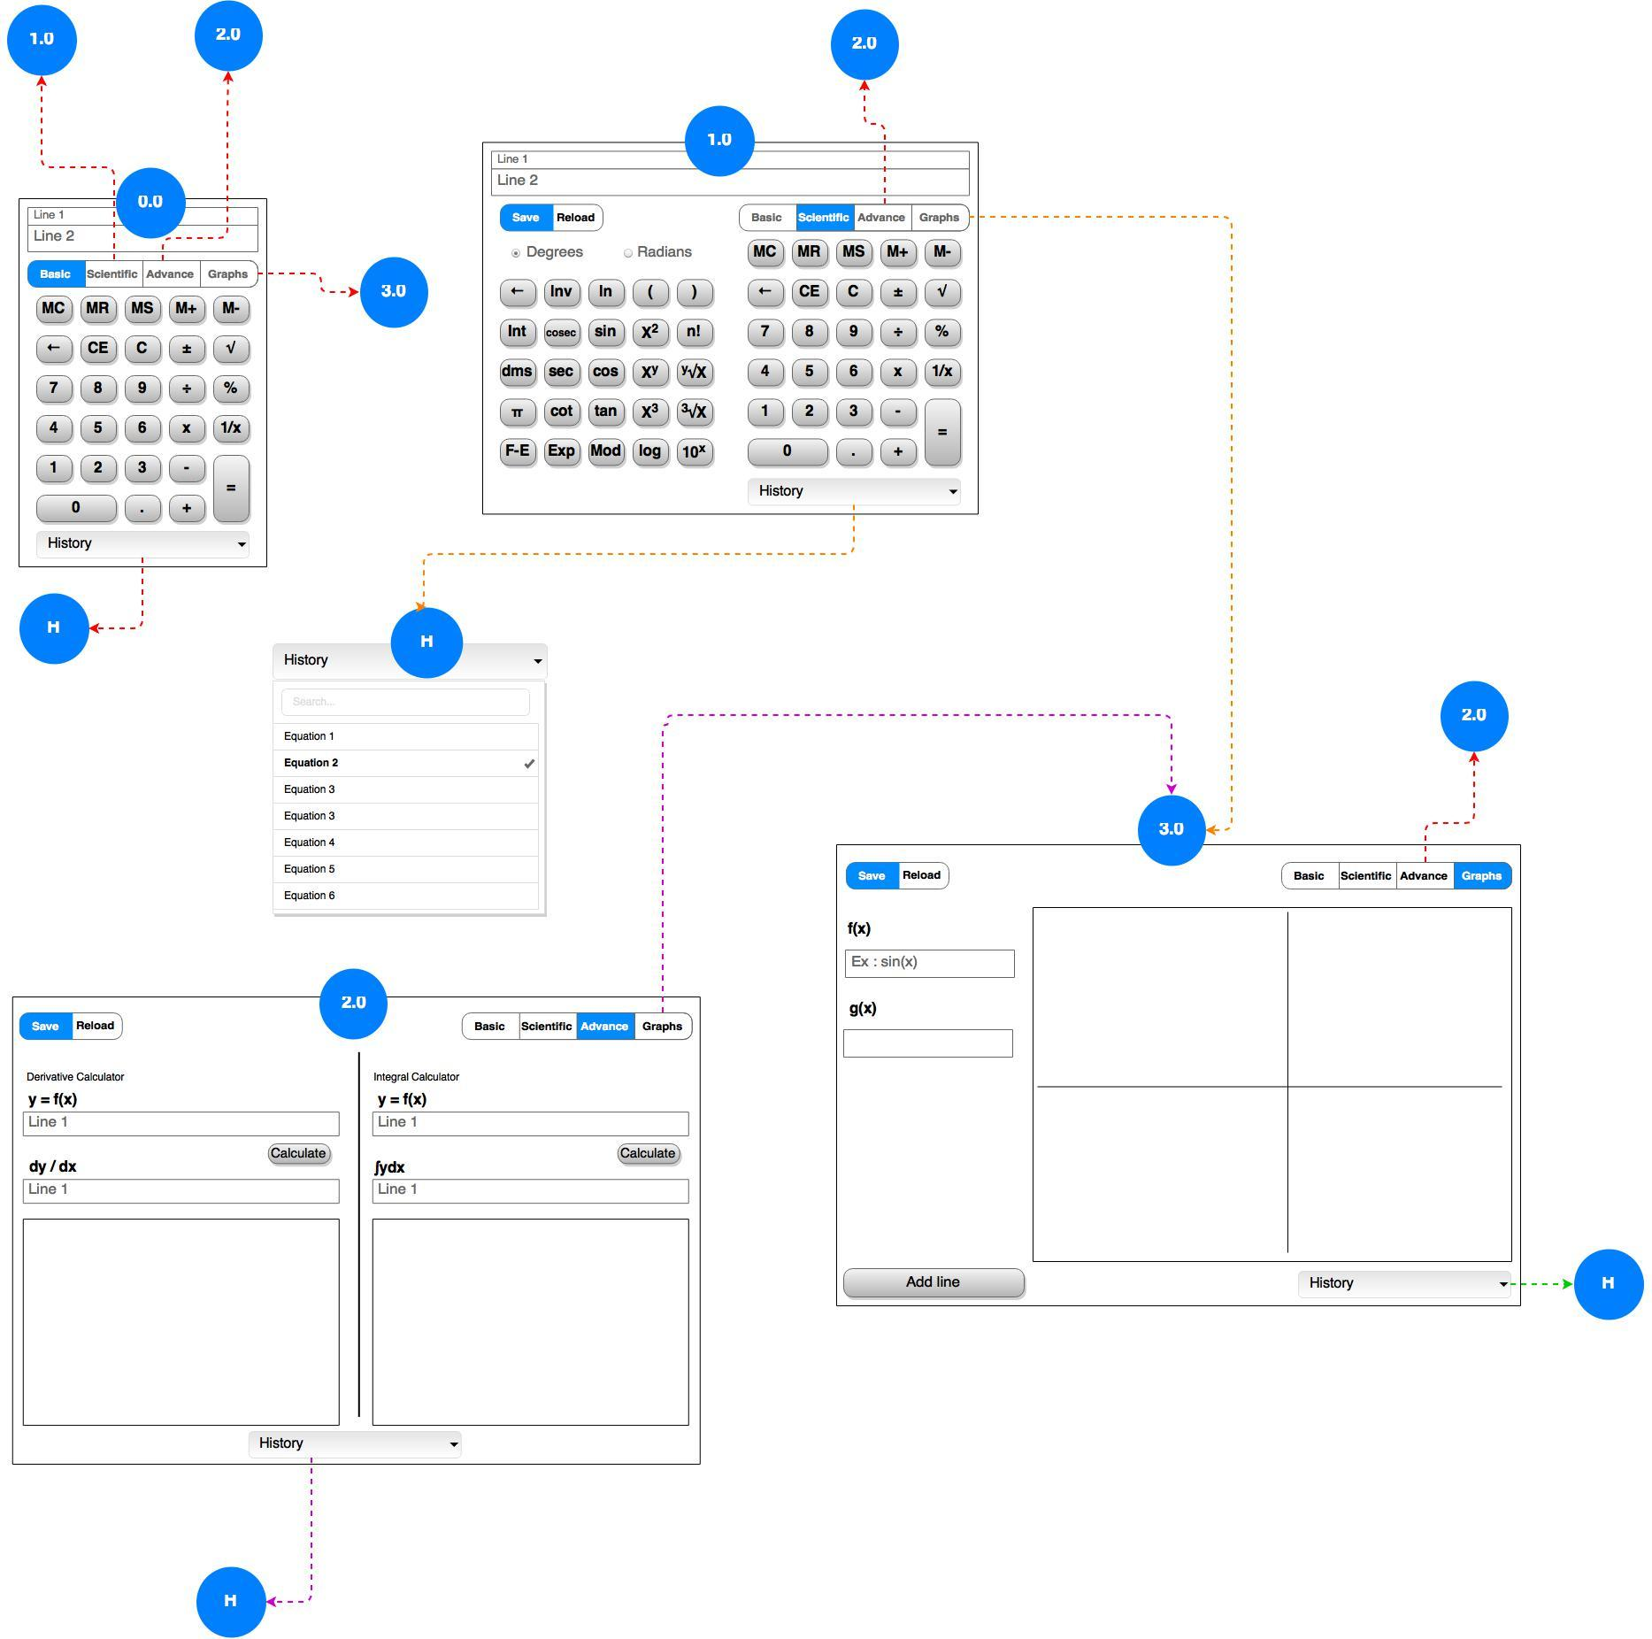

Read more - <https://goo.gl/op10hY>

## **User Interface**

* + 1. Splash Screen

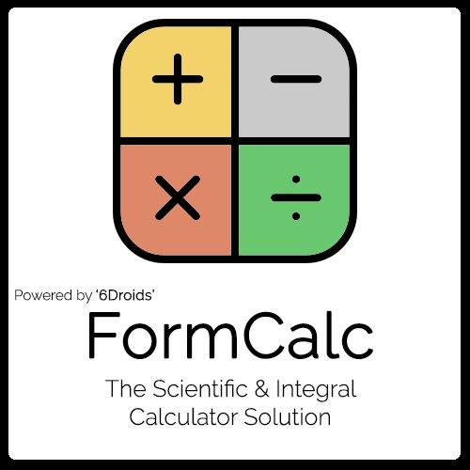

*Figure 1 - Splash Screen*

* + 1. Basic Calculator

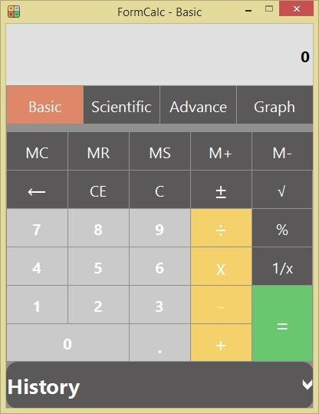

*Figure 2 - Basic Calculator*

2.4.3 Scientific Calculator

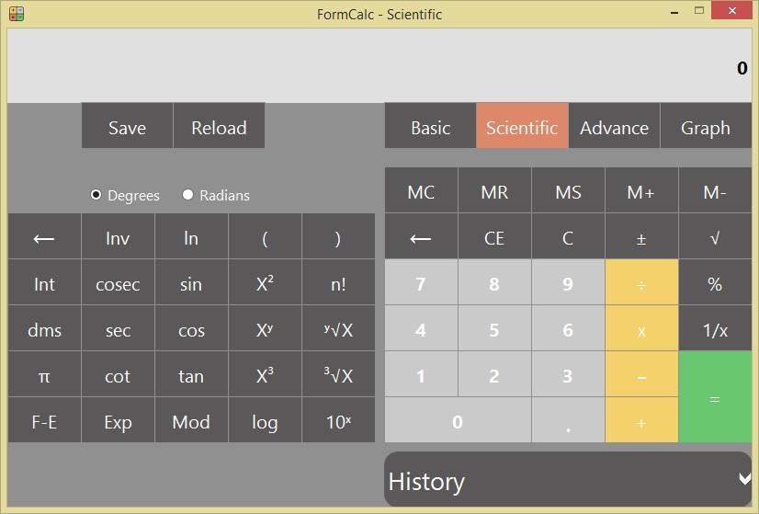

*Figure 3 - Scientific Calculator*

2.4.4 Advance Calculator

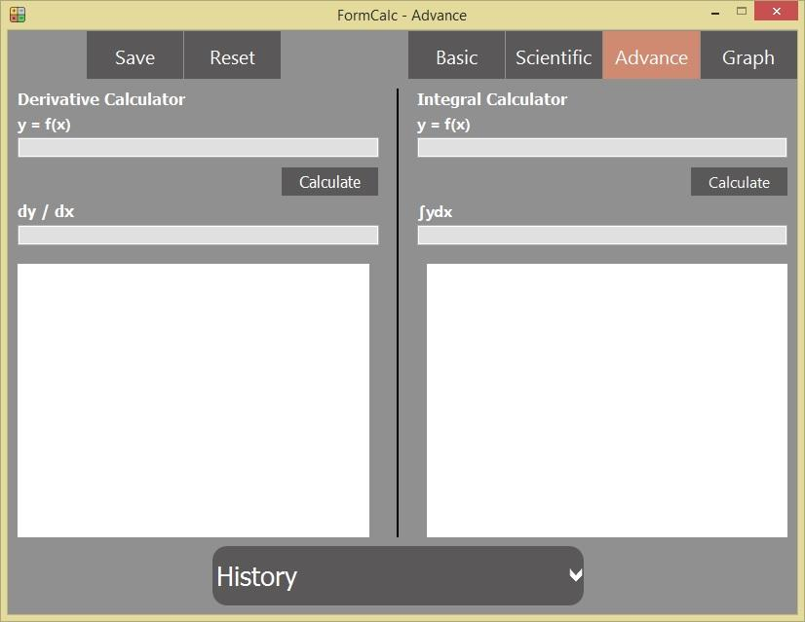

*Figure 4 - Advance Calculator*

2.4.5 Graph Calculator

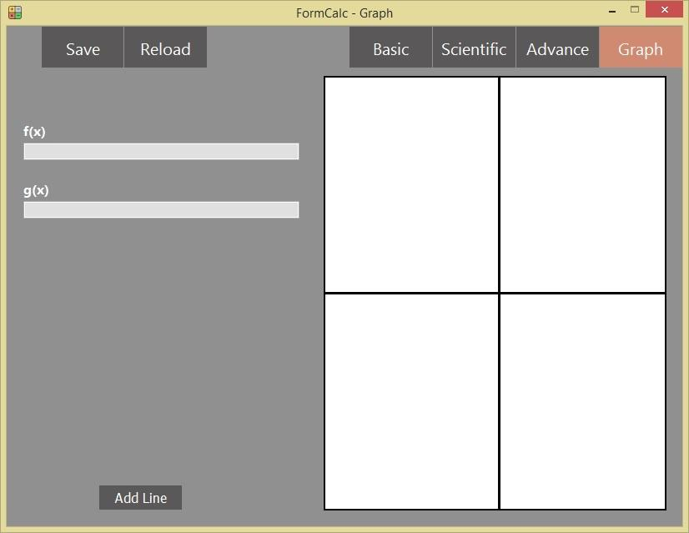

*Figure 5 - Graph Calculator*

# Analysis of Success / Failure

From the day one we worked hard on our project. Sailed through so many difficult tasks and with dedication, team spirit we managed to overcome all barriers, difficulties to make it a success. Even though there were few short comings we made it a success.

Below mention tasks are what we achieved

* Research and development brought up to 92.50% success
* Requirement analysis reached 93.33%
* UI, UX & Prototyping achieved 95.00% success
* 97.50% success for Architecture
* Out of developing Basic match function, History implementation, Formula storage and Formula evaluation succeeded 85.00% up to now.

There were few failures in the project we couldn’t achieve. They are,

* There is another failure we had with QA issues. We planned our software to be tested with “Automation”. To test with “Automation” we need a tool which needs to be studied. We had to stop testing from automation because it takes time to learn that tool.
* It takes considerable time to develop test cases when testing software by using “Automation”. On this stage spending on that is a risk.
* As another feature we tried to add a “Currency Converter” to the “FormCalc”, but we failed due to time barriers.

# Additional Features

We thought of developing “FormCalc” by adding some features where it becomes more attractive, user friendly and easy to use.

That is why the User Interface was designed as a “Flat Design”. It gives better and smart look for the “FormCalc” than a normal User Interface design.

Another feature is all calculations done by user saved in the history, but erases once the “FormCalc” is closed.

Another feature we wanted to add was “Currency Converter”. But we mentioned before, we couldn’t achieve it.

# Team Analysis

## **5.1 Team Roles**

First thing we did in the project was delegating roles between team members. So we created a spreadsheet in Google Drive to vote team members for their expertise. We voted team members for their areas of expertise and at the same time vote ourselves for our strong areas. Through that we selected the best for their strengths accordingly.

|  | Tharkana (T) | | | | | | Nelanga (Ne) | | | | | | Poorni (Po) | | | | | | Kavindu (K) | | | | | | Namal (Na) | | | | | | Priyanga (Pr) | | | | | |
| --- | --- | --- | --- | --- | --- | --- | --- | --- | --- | --- | --- | --- | --- | --- | --- | --- | --- | --- | --- | --- | --- | --- | --- | --- | --- | --- | --- | --- | --- | --- | --- | --- | --- | --- | --- | --- |
|  | T | Ne | Po | K | Na | Pr | T | Ne | Po | K | Na | Pr | T | Ne | Po | K | Na | Pr | T | Ne | Po | K | Na | Pr | T | Ne | Po | K | Na | Pr | T | Ne | Po | K | Na | Pr |
| Team Leader |  |  |  |  |  |  |  |  |  |  |  |  |  |  |  |  |  |  |  |  |  |  |  |  |  |  |  |  |  |  |  |  |  |  |  |  |
| Report Writers |  |  |  |  |  |  |  |  |  |  |  |  |  |  |  |  |  |  |  |  |  |  |  |  |  |  |  |  |  |  |  |  |  |  |  |  |
| UI Designers |  |  |  |  |  |  |  |  |  |  |  |  |  |  |  |  |  |  |  |  |  |  |  |  |  |  |  |  |  |  |  |  |  |  |  |  |
| Developers |  |  |  |  |  |  |  |  |  |  |  |  |  |  |  |  |  |  |  |  |  |  |  |  |  |  |  |  |  |  |  |  |  |  |  |  |
| QA |  |  |  |  |  |  |  |  |  |  |  |  |  |  |  |  |  |  |  |  |  |  |  |  |  |  |  |  |  |  |  |  |  |  |  |  |

| **Task** | **Assigned Persons** | **Follow up** |
| --- | --- | --- |
| *Team Leader* | Tharkana |  |
| *Report Writers* | Poorni / Namal | Kavindu |
| *UI Designers* | Nelanga / Kavindu | Team |
| *Developers* | Tharkana / Priyanga / Kavindu / Nelanga |  |
| *QA* | Poorni / Namal | Team |

| Dev Team | Tharkana, Priyanga, Kavindu, Nelanga |
| --- | --- |
| Designing Team | Nelanga, Kavindu |
| Documentation Team (Reporting, QA) | Poorni, Namal |

# Conclusion

Past few couple of weeks had been a very busy period for us. From the day one we started the project it became harder by day. With some of our team members work schedules we had a tough time for the project.

We've been a great team till this moment we present our project. That's why we could make it a success even though we had some few barriers and short comings.

We had to learn so many new things when we were doing the project.

With all the lessons learnt through mistakes, challenges and specially with a great team spirit finally we made it a success.